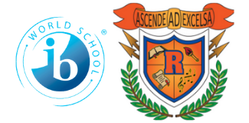

Ridgeway International Baccalaureate

Middle World Optional School

2023-2024

8th Grade School Supply List

Loose Leaf Notebook Paper (10 packs – 5 each semester)

144 – No. 2 Pencils **(Wood or Mechanical)**

*\*\*If purchasing mechanical pencils, please purchase lead also.*

Pens (red, black, and blue)

Highlighters (multi-color pack)

Kleenex – 2 boxes **(Homeroom teachers will collect the 1st week of school)**

Lysol/Clorox Wipes Unscented **(Homeroom teachers will collect 1st week of school)**

Post-It Notes

Headphones or Ear buds for computer use (Requirement – not Airpods)

6 – two-pocket folders with prongs (Each teacher will collect 1st week of school)

Preferred Folder Colors: Blue, Red, Yellow, Green, Purple, Orange

Scientific Calculator (TI-30XS)

 – *for non-Algebra* *1 students* to use at home

Backpack (Has to fit in student’s locker)

Locker Rental Fee: $5 (Mandatory for ALL students – pay to Homeroom teacher)